“AKBAR BIZNES STROY ” MChJ (Sirdaryo viloyati)
Telefon raqam: +998 93 324 27 23
E-mail pochtа: uran3325@gmail.com
Mahsulotning rasmi | artikul | Nomi | Texnik xususiyatlari | Maxsulot narxi dollarda (QQS bilan)
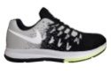 | 003 подрасковий | "Zinnur"NIKE | Havo o’tqazuvchi maxsus matodan tayyorlangan | 9
 | NIKE-003 | "Zinnur"NIKE | Havo o’tqazuvchi maxsus matodan tayyorlangan | 10
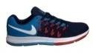 | zoom-007 | "Zinnur"NIKE | Havo o’tqazuvchi maxsus matodan tayyorlangan | 9
 | 008  подрасковий | "Zinnur"NIKE | Havo o’tqazuvchi maxsus matodan tayyorlangan | 9
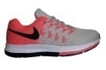 | NIKE-009 | "Zinnur"NIKE | Havo o’tqazuvchi maxsus matodan tayyorlangan | 9
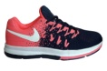 | NIKE-010 | "Zinnur"NIKE | Havo o’tqazuvchi maxsus matodan tayyorlangan | 9
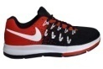 | NIKE-011 | "Zinnur"NIKE | Havo o’tqazuvchi maxsus matodan tayyorlangan | 9
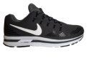 | NIKE zoom-015 | "Zinnur"NIKE | Havo o’tqazuvchi maxsus matodan tayyorlangan | 11
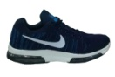 | NIKE-023 | "Zinnur"NIKE | Havo o’tqazuvchi maxsus matodan tayyorlangan | 11
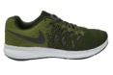 | NIKE-024 | "Zinnur"NIKE | Havo o’tqazuvchi maxsus matodan tayyorlangan | 11
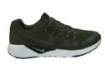 | NIKE-028 | "Zinnur"NIKE | Havo o’tqazuvchi maxsus matodan tayyorlangan | 11
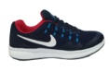 | NIKE-029 | "Zinnur"NIKE | Havo o’tqazuvchi maxsus matodan tayyorlangan | 11
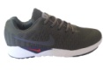 | NIKE-030 | "Zinnur"NIKE | Havo o’tqazuvchi maxsus matodan tayyorlangan | 11
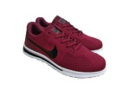 | NIKE-067 | "Zinnur"NIKE | Havo o’tqazuvchi maxsus matodan tayyorlangan | 7
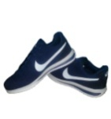 | NIKE-069 | "Zinnur"NIKE | Havo o’tqazuvchi maxsus matodan tayyorlangan | 7
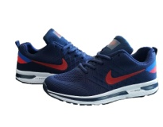 | NIKE zoom-122 | "Zinnur"NIKE | Havo o’tqazuvchi maxsus matodan tayyorlangan | 7
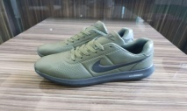 | NIKE zoom-171 | "Zinnur"NIKE | Tabiiy teridan tayyorlangan | 7
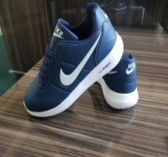 | NIKE zoom-172 | "Zinnur"NIKE | Tabiiy teridan tayyorlangan | 7
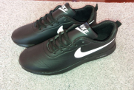 | NIKE-177 | "Zinnur"NIKE | Tabiiy teridan tayyorlangan | 7
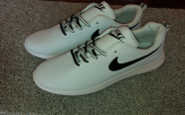 | NIKE-178 | "Zinnur"NIKE | Tabiiy teridan tayyorlangan | 7
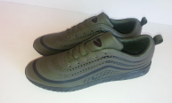 | NIKE-180 | "Zinnur"NIKE | Tabiiy teridan tayyorlangan | 7
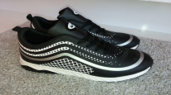 | NIKE-181 | "Zinnur"NIKE | Nubukdan tayyorlangan | 7
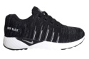 | "Zinnur"Air-Max-016 | AIR-MAX ZN | Nubukdan tayyorlangan | 11
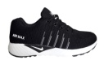 | "Zinnur"Air-Max-019 | AIR-MAX ZN | Nubukdan tayyorlangan | 11
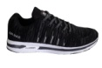 | "Zinnur"Air-Max zoom-025 | AIR-MAX ZN | Nubukdan tayyorlangan | 11
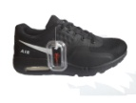 | "Zinnur"Air-Max-046 | AIR-MAX ZN | Nubukdan tayyorlangan | 8
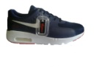 | "Zinnur"Air-Max-048 | AIR-MAX ZN | Nubukdan tayyorlangan | 8
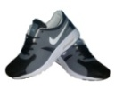 | "Zinnur"Air-Max-074 | AIR-MAX ZN | Nubukdan tayyorlangan | 8
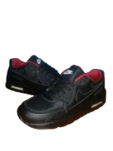 | "Zinnur"Air Max-075 | AIR-MAX ZN | Nubukdan tayyorlangan | 9
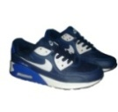 | "Zinnur"Air Max-076 | AIR-MAX ZN | Nubukdan tayyorlangan | 9
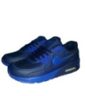 | "Zinnur"Air Max-077 | AIR-MAX ZN | Nubukdan tayyorlangan | 9
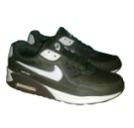 | "Zinnur"Air Max-076 | AIR-MAX ZN | Nubukdan tayyorlangan | 9
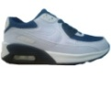 | "Zinnur"Air Max-079 | AIR-MAX ZN | Nubukdan tayyorlangan | 9
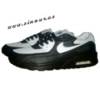 | "Zinnur"Air Max-080 | AIR-MAX ZN | Nubukdan tayyorlangan | 9
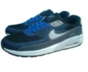 | "Zinnur"Air Max-081 | AIR-MAX ZN | Nubukdan tayyorlangan | 9
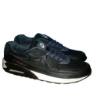 | "Zinnur"Air Max-082 | AIR-MAX ZN | Nubukdan tayyorlangan | 9
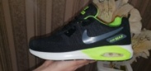 | "Zinnur"Air Max-123 | AIR-MAX ZN | Nubukdan tayyorlangan | 9
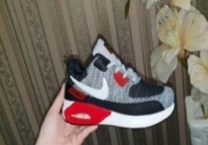 | "Zinnur"Air Max-124 | AIR-MAX ZN | Nubukdan tayyorlangan | 9
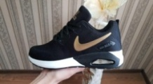 | "Zinnur"Air Max-125 | AIR-MAX ZN | Nubukdan tayyorlangan | 9
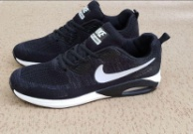 | "Zinnur"Air Max-129 | AIR-MAX ZN | Nubukdan tayyorlangan | 9
 | "Zinnur"Air Max-130 | AIR-MAX ZN | Nubukdan tayyorlangan | 9
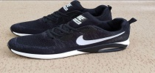 | "Zinnur"Air Max-141 | AIR-MAX ZN | Nubukdan tayyorlangan | 9
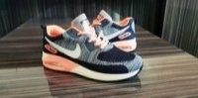 | ZinnurAir Max-148 | AIR-MAX ZN | Nubukdan tayyorlangan | 9
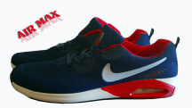 | "Zinnur"Air Max-150 | AIR-MAX ZN | Nubukdan tayyorlangan | 9
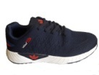 | "Zinnur"Adidas Neo-034 | ADIDAS ZN | Nubukdan tayyorlangan | 7
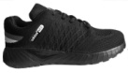 | "Zinnur"Adidas Neo-037 | ADIDAS ZN | Nubukdan tayyorlangan | 7
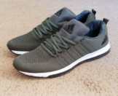 | "Zinnur"Adidas-126 | ADIDAS ZN | Nubukdan tayyorlangan | 9
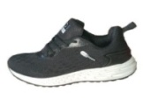 | "Zinnur"Adidas Neo-128 | ADIDAS ZN | Nubukdan tayyorlangan | 8
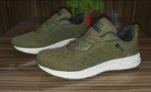 | "Zinnur"Adidas Neo-132 | ADIDAS ZN | Nubukdan tayyorlangan | 8
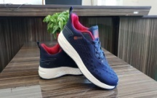 | "Zinnur"Adidas-140 | ADIDAS ZN | Nubukdan tayyorlangan | 8
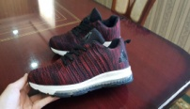 | "Zinnur"Adidas Neo-034 | 2ADIDAS ZN | Nubukdan tayyorlangan | 9
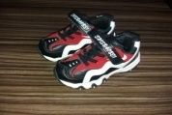 | Zinnur Air-165 | AIR-ZN | Nubukdan tayyorlangan | 9
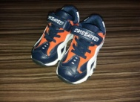 | Zinnur Air-166 | AIR-ZN | Nubukdan tayyorlangan | 9
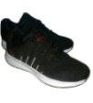 | "Zinnur"ZN-058 | ZINNUR | Nubukdan tayyorlangan | 8
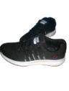 | "Zinnur"ZN-059 | ZINNUR | Havo o’tqazuvchi maxsus matodan tayyorlangan | 8
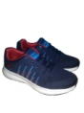 | "Zinnur"ZN-060 | ZINNUR | Havo o’tqazuvchi maxsus matodan tayyorlangan | 8
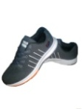 | "Zinnur"ZN-061 | ZINNUR | Havo o’tqazuvchi maxsus matodan tayyorlangan | 8
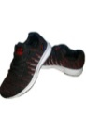 | "Zinnur"ZN-064 | ZINNUR | Havo o’tqazuvchi maxsus matodan tayyorlangan | 8
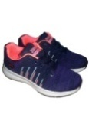 | "Zinnur"ZN-065 | ZINNUR | Havo o’tqazuvchi maxsus matodan tayyorlangan | 8
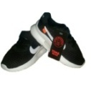 | "Zinnur"ZN-083 | ZINNUR | Havo o’tqazuvchi maxsus matodan tayyorlangan | 8
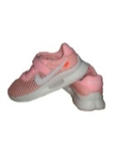 | "Zinnur"ZN-084 | ZINNUR | Havo o’tqazuvchi maxsus matodan tayyorlangan | 8
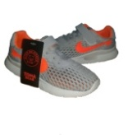 | "Zinnur"ZN-085 | ZINNUR | Havo o’tqazuvchi maxsus matodan tayyorlangan | 8
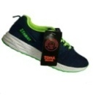 | "Zinnur"ZN-086 | ZINNUR | Nubukdan tayyorlangan | 8
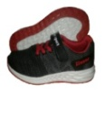 | "Zinnur"ZN-088 | ZINNUR | Nubukdan tayyorlangan | 8
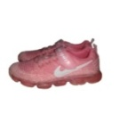 | "Zinnur"ZN-089 | ZINNUR | Nubukdan tayyorlangan | 8
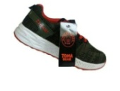 | "Zinnur"ZN-090 | ZINNUR | Nubukdan tayyorlangan | 8
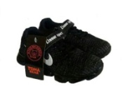 | "Zinnur"ZN-091 | ZINNUR | Nubukdan tayyorlangan | 8
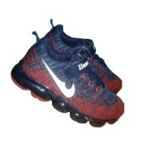 | "Zinnur"ZN-092 | ZINNUR | Nubukdan tayyorlangan | 8
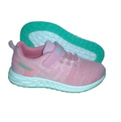 | "Zinnur"ZN-093 | ZINNUR | Nubukdan tayyorlangan | 8
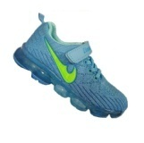 | "Zinnur"ZN-094 | ZINNUR | Nubukdan tayyorlangan | 8
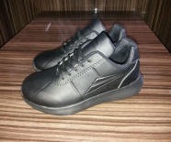 | "Zinnur"ZN-170 | ZINNUR | Nubukdan tayyorlangan | 8
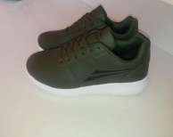 | "Zinnur"ZN-179 | ZINNUR | Nubukdan tayyorlangan | 8
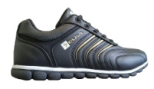 | "Zinnur"Kajila -143 | ZINNUR | Nubukdan tayyorlangan | 8
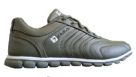 | "Zinnur"Kajila -145 | ZINNUR | Nubukdan tayyorlangan | 8
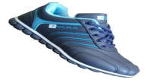 | "Zinnur"Kajila -146 | ZINNUR | Nubukdan tayyorlangan | 8
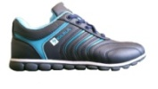 | Zinnur Kajila -147 | ZINNUR | Nubukdan tayyorlangan | 8
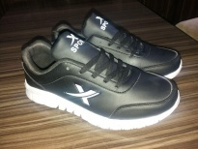 | "Zinnur" Sport-173 подрос | SPORT | Nubukdan tayyorlangan | 6
 | "Zinnur" Sport-173 | SPORT | Nubukdan tayyorlangan | 6
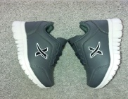 | "Zinnur" Sport-174 подрос | SPORT | Nubukdan tayyorlangan | 6
 | "Zinnur" Sport-174 | SPORT | Nubukdan tayyorlangan | 6

“CAST SHOES” MChJ (Andijon viloyati)
Telefon raqam: +998 93 441 25 25
E-mail pochta: cast_shoes@mail.ru

Mahsulotning rasmi | artikul | Nomi | Texnik xususiyatlari | Maxsulot narxi dollarda (QQS bilan)
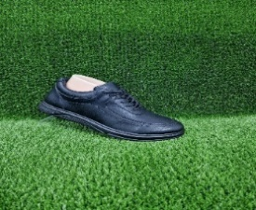 | 23/29 | Erkaklar krasofkasi | Yuqori sifatli karafan, rangi qora, poliuretanidan quyma taglik | 4,0
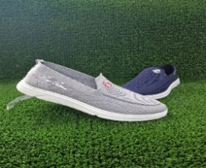 | 23/302 | Erkaklar krasofkasi | To’qimachilik setka material, rangi ko’k va qora, poliuretanidan quyma taglik | 3,5
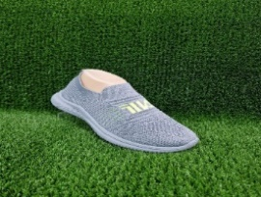 | 23/207 | O’smirlar krasofkasi | To’qimachilik setka material, rangi kul rang, poliuretanidan quyma taglik | 3,0
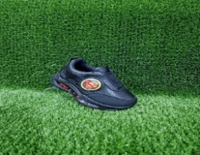 | 23/19 | Bolalar krasofkasi | Yuqori sifatli karafan, rangi qora, poliuretanidan quyma taglik | 3,0
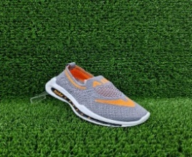 | 23/207 | Bolalarr krasofkasi | To’qimachilik setka material, rangi kul rang, poliuretanidan quyma taglik | 3,0
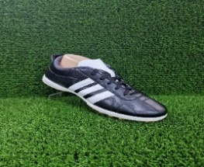 | 1213 | Erkaklar poyabzali | Yuqori sifatli karafan, rangi qora, PVC quyma taglik | 4,5

